Test Case: runTestMultipleTimes
Step 1 - Enter username and password and click to button Enter : Credentials Entered
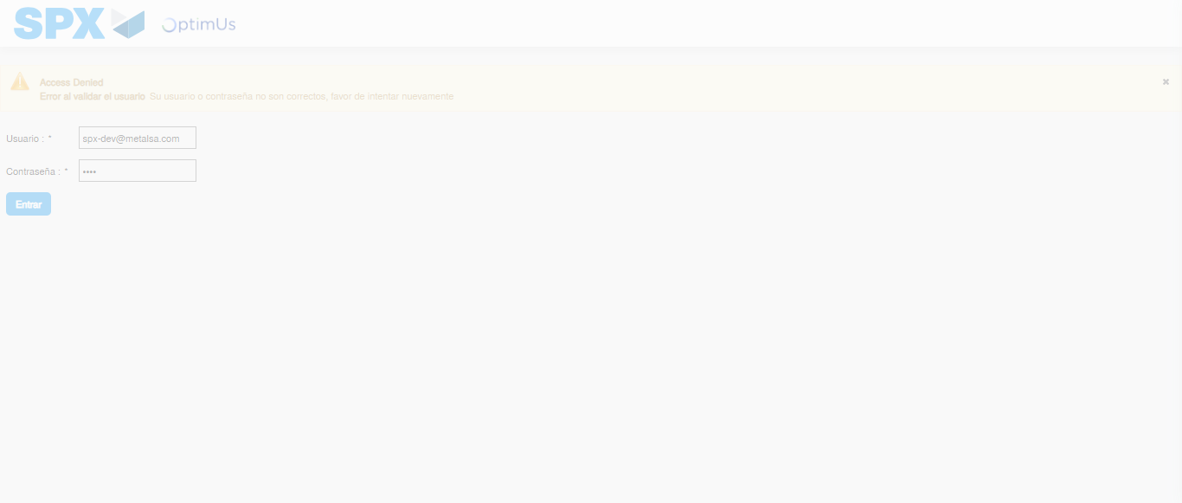Image file-name: QC_Testing-runTestMultipleTimes-nov. 25 2025, 03 58 43 p. m.

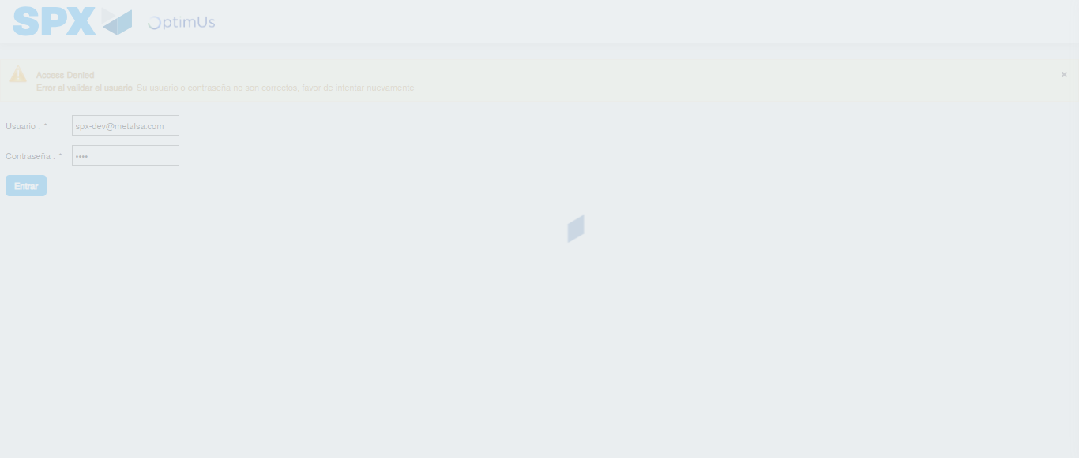Image file-name: QC_Testing-runTestMultipleTimes-nov. 25 2025, 03 58 44 p. m.

Step 2 - Select to UEN and Access to Spot Buy Requisitions : UEN Correctly selected and Correct access
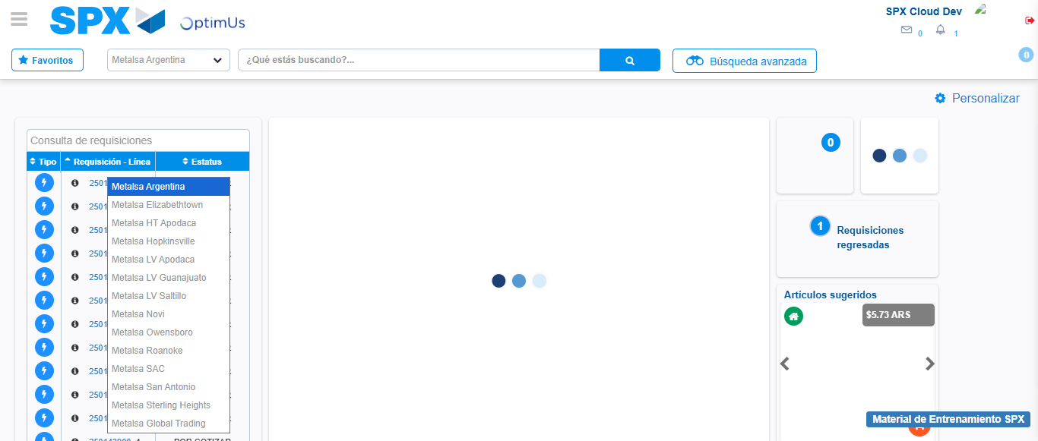Image file-name: QC_Testing-runTestMultipleTimes-nov. 25 2025, 03 58 48 p. m.

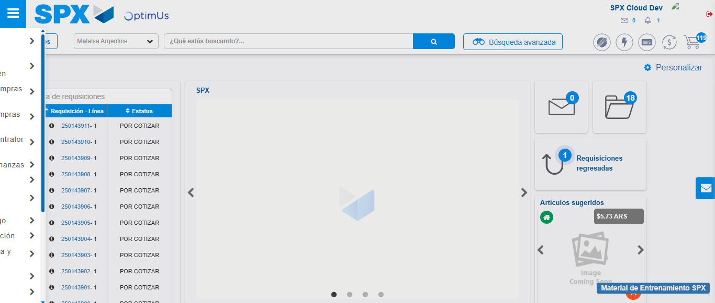Image file-name: QC_Testing-runTestMultipleTimes-nov. 25 2025, 03 58 49 p. m.

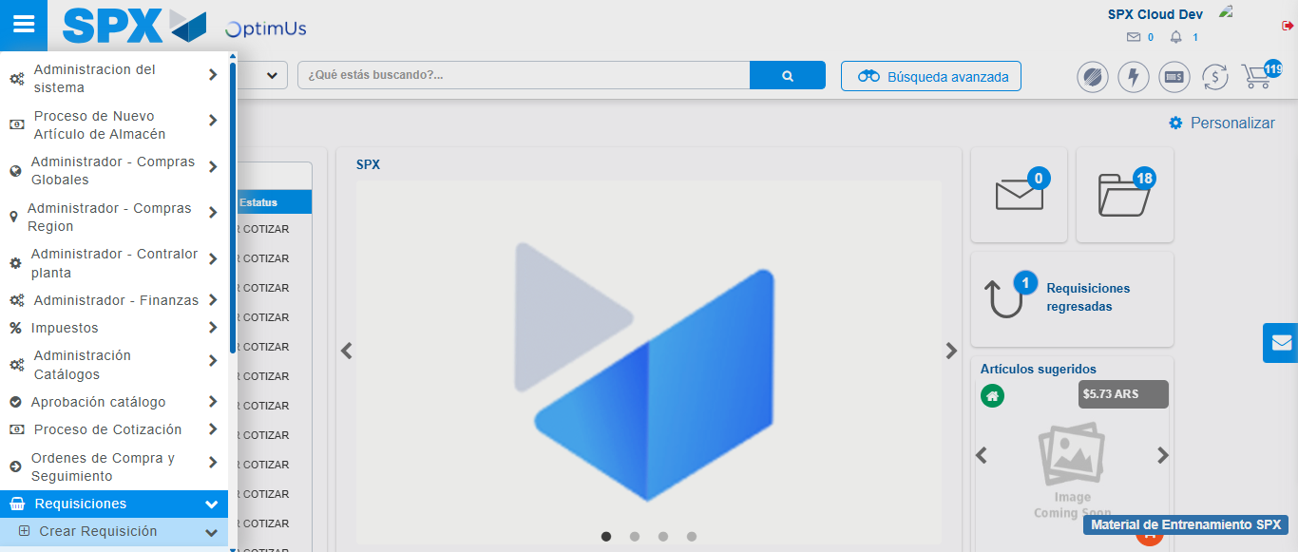Image file-name: QC_Testing-runTestMultipleTimes-nov. 25 2025, 03 58 50 p. m.

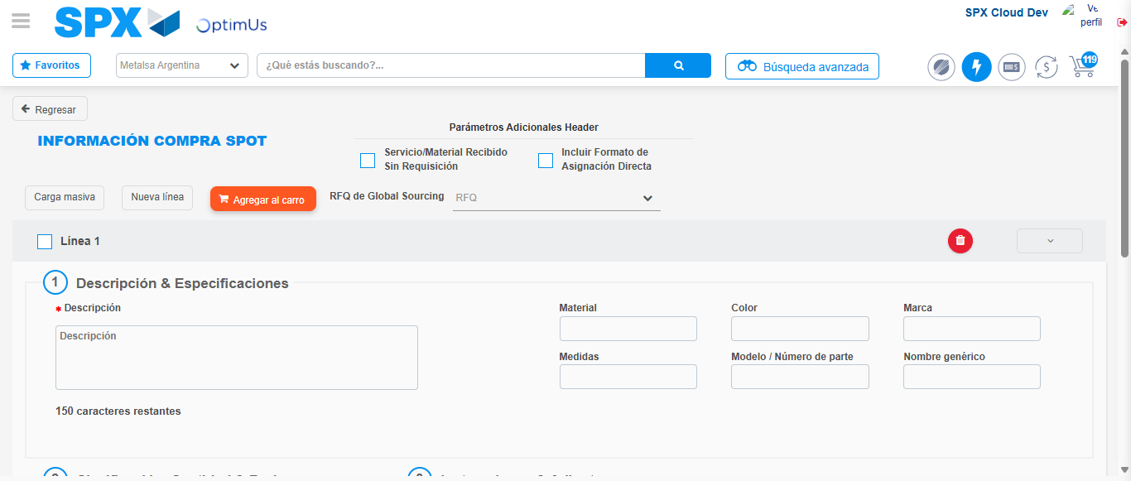Image file-name: QC_Testing-runTestMultipleTimes-nov. 25 2025, 03 58 53 p. m.

Step 3 - Data Capture Spot Buy Requisition : Data captured correctly
Image file-name: QC_Testing-runTestMultipleTimes-nov. 25 2025, 03 58 53 p. m.

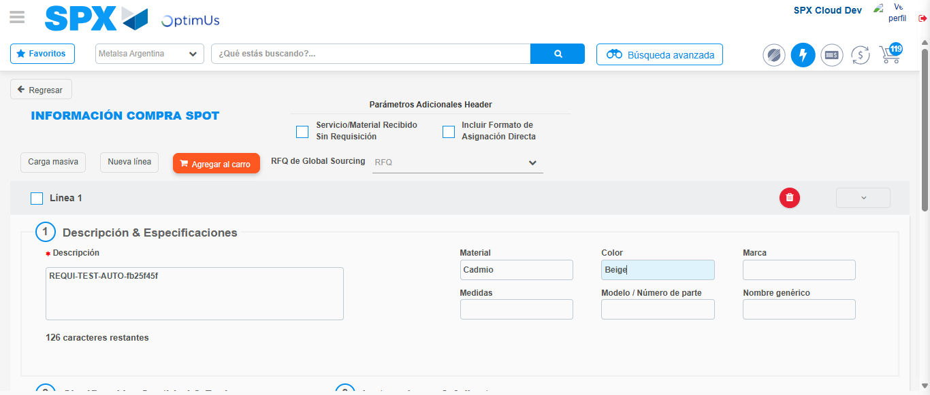Image file-name: QC_Testing-runTestMultipleTimes-nov. 25 2025, 03 58 54 p. m.

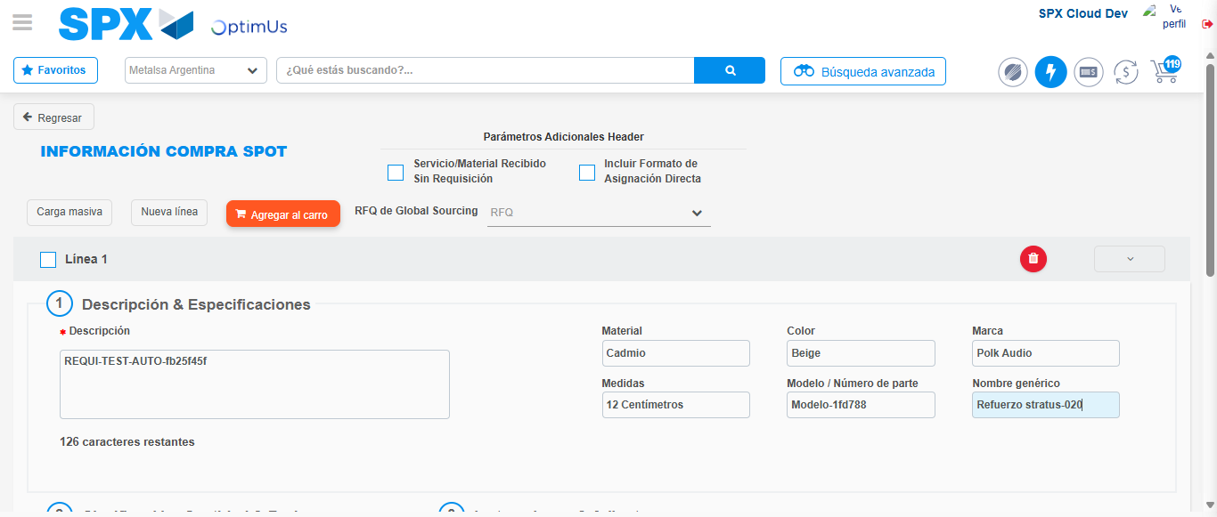Image file-name: QC_Testing-runTestMultipleTimes-nov. 25 2025, 03 58 55 p. m.

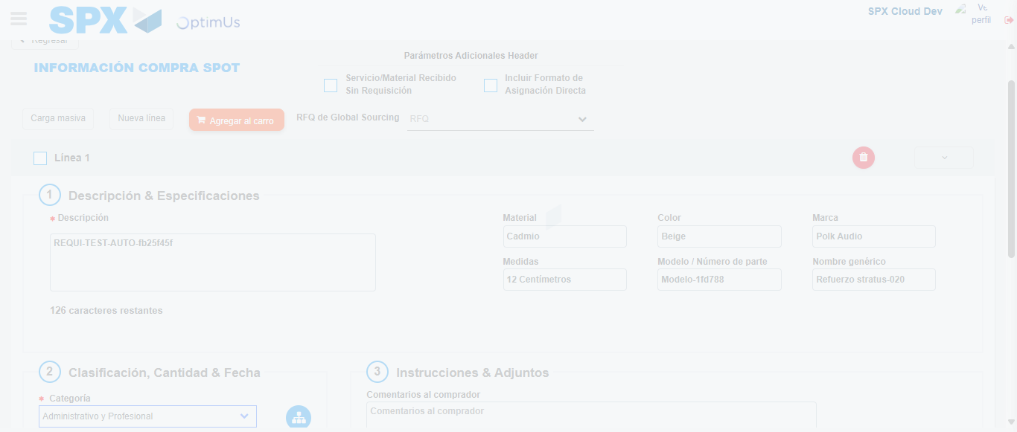Image file-name: QC_Testing-runTestMultipleTimes-nov. 25 2025, 03 58 56 p. m.

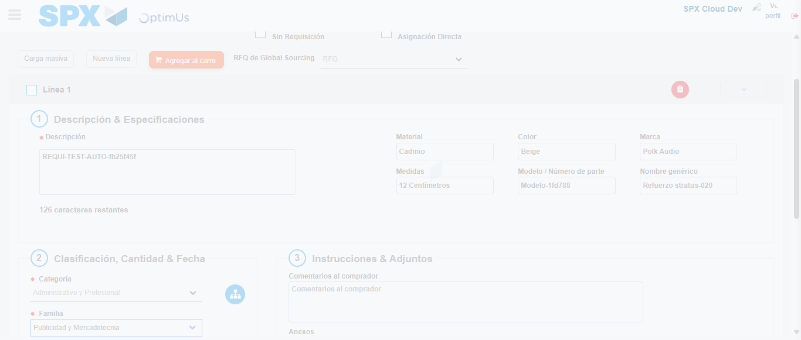Image file-name: QC_Testing-runTestMultipleTimes-nov. 25 2025, 03 58 57 p. m.

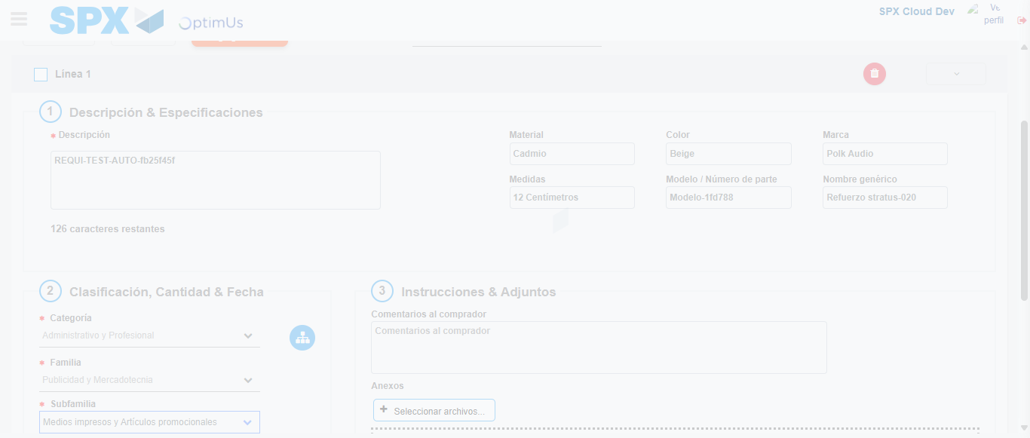Image file-name: QC_Testing-runTestMultipleTimes-nov. 25 2025, 03 58 58 p. m.

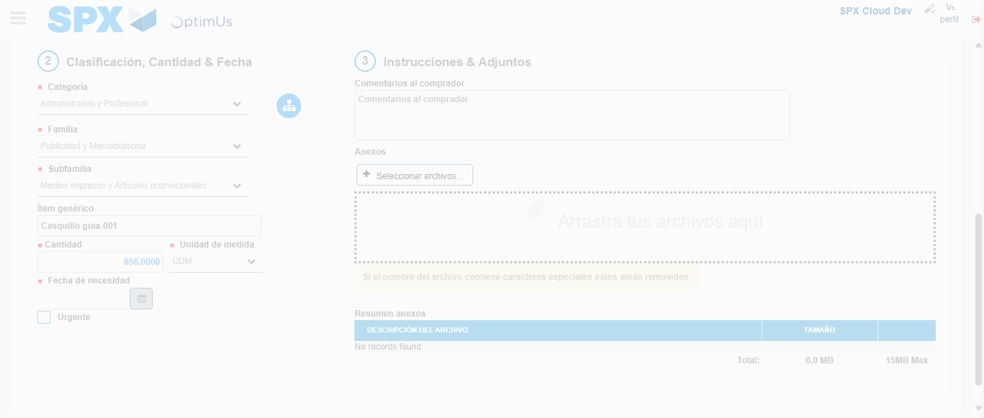Image file-name: QC_Testing-runTestMultipleTimes-nov. 25 2025, 03 58 59 p. m.

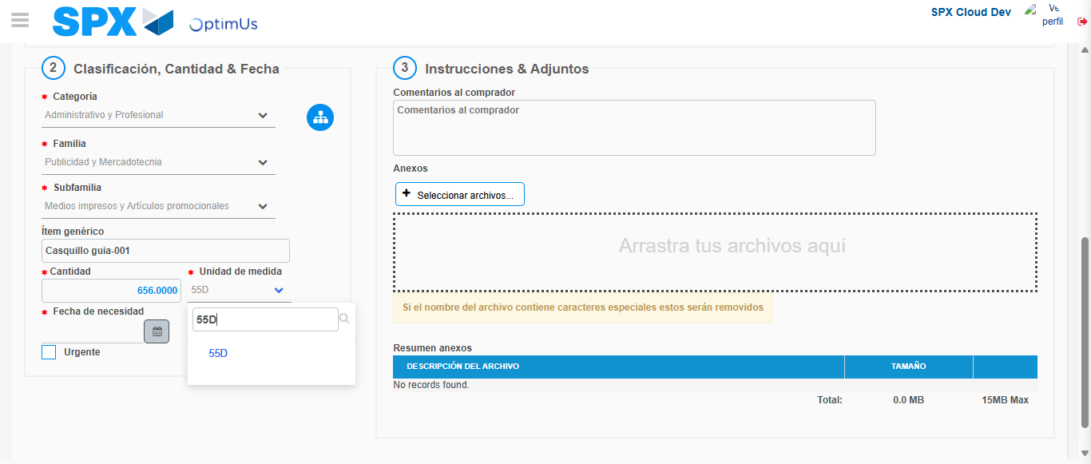Image file-name: QC_Testing-runTestMultipleTimes-nov. 25 2025, 03 59 00 p. m.

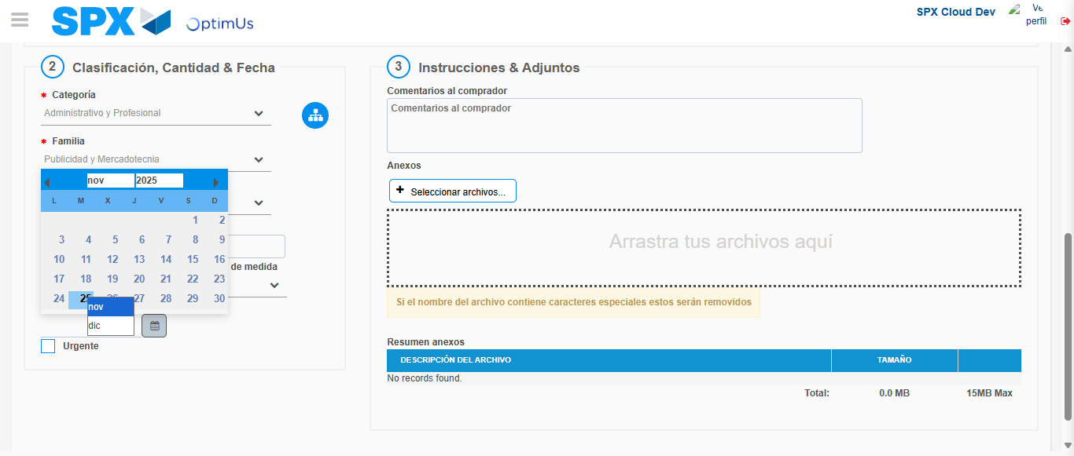Image file-name: QC_Testing-runTestMultipleTimes-nov. 25 2025, 03 59 01 p. m.

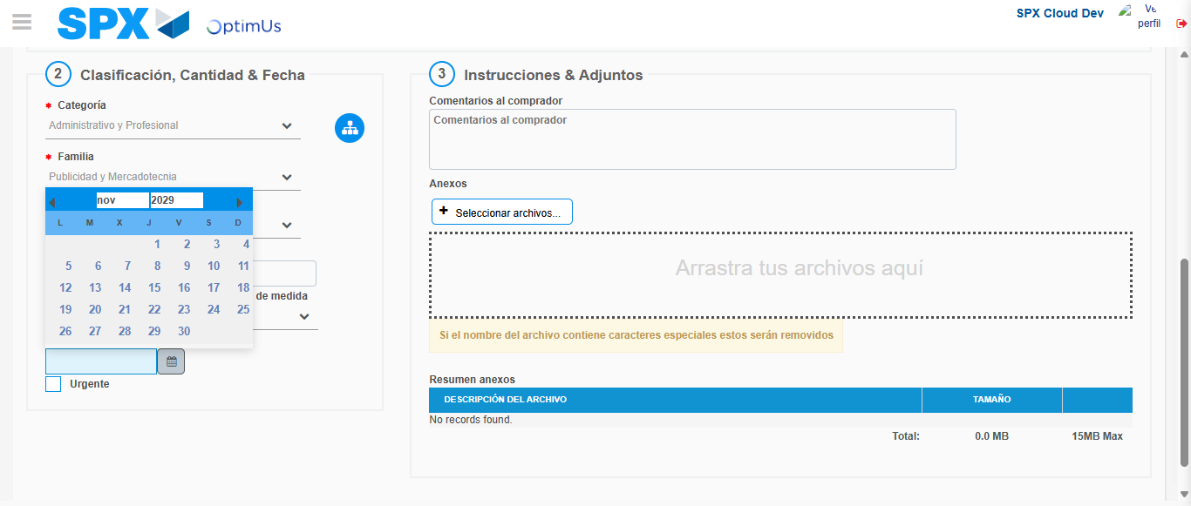Image file-name: QC_Testing-runTestMultipleTimes-nov. 25 2025, 03 59 02 p. m.

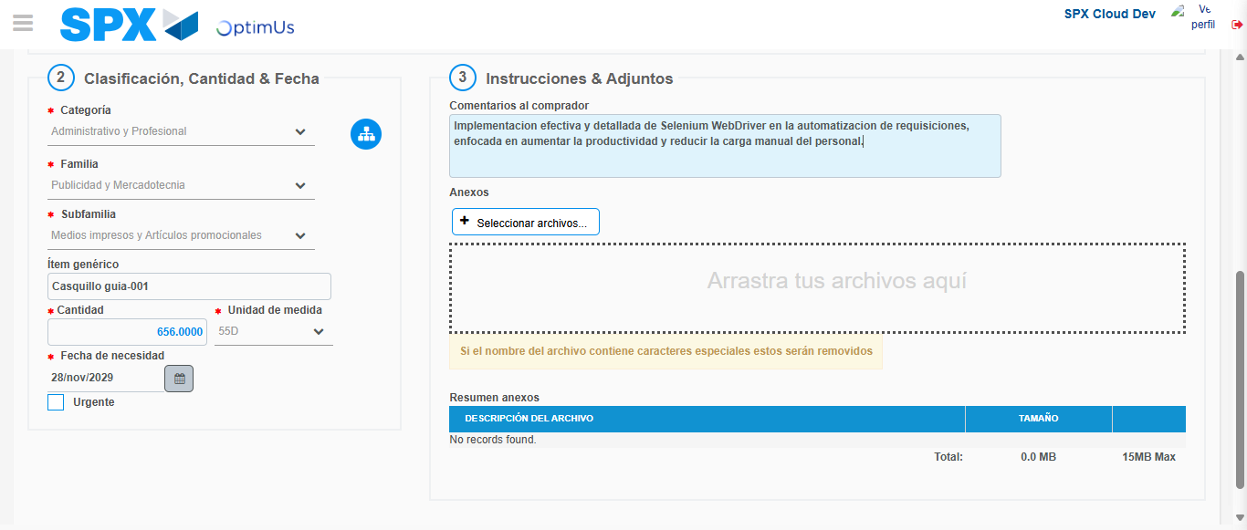Image file-name: QC_Testing-runTestMultipleTimes-nov. 25 2025, 03 59 03 p. m.

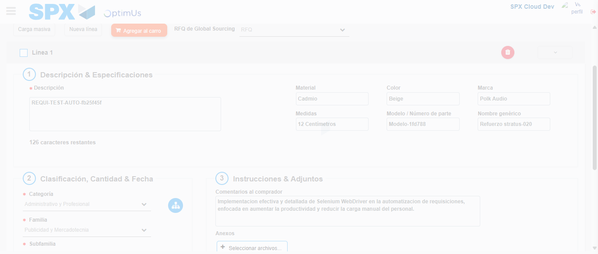Image file-name: QC_Testing-runTestMultipleTimes-nov. 25 2025, 03 59 04 p. m.

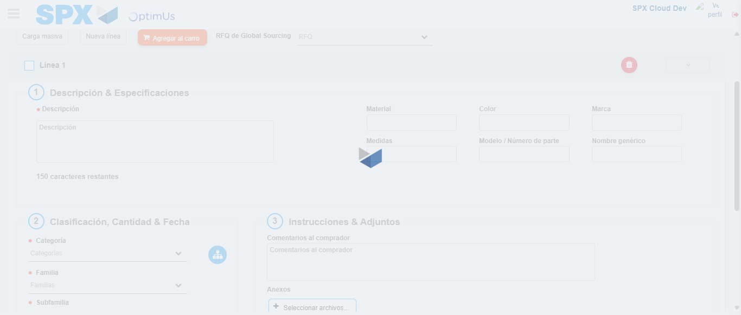Image file-name: QC_Testing-runTestMultipleTimes-nov. 25 2025, 03 59 05 p. m.

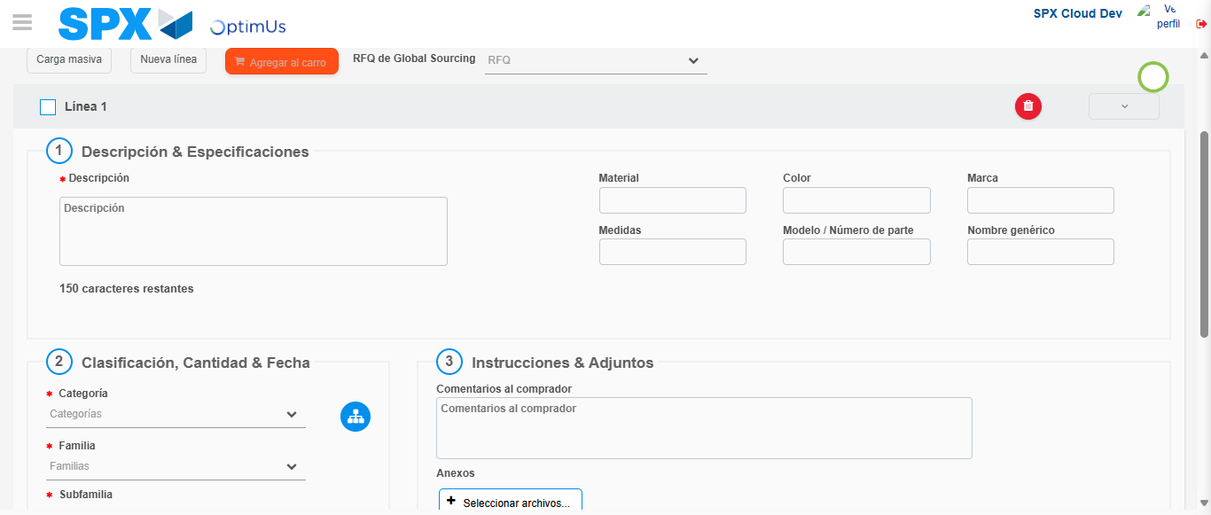Image file-name: QC_Testing-runTestMultipleTimes-nov. 25 2025, 03 59 06 p. m.

Step 4 - Select to Requisition : Requisition Correctly selected
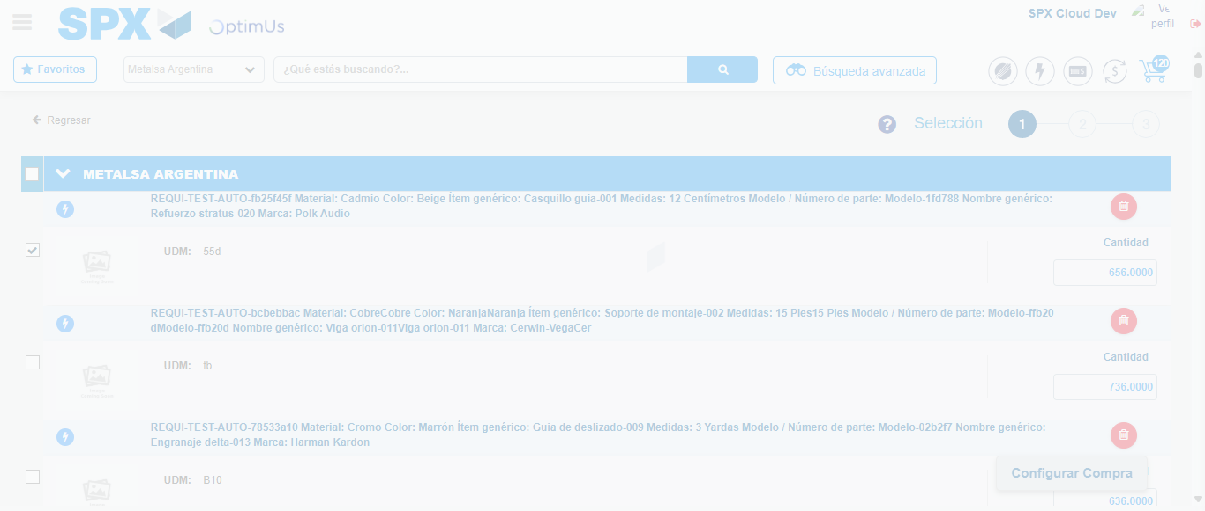Image file-name: QC_Testing-runTestMultipleTimes-nov. 25 2025, 03 59 14 p. m.

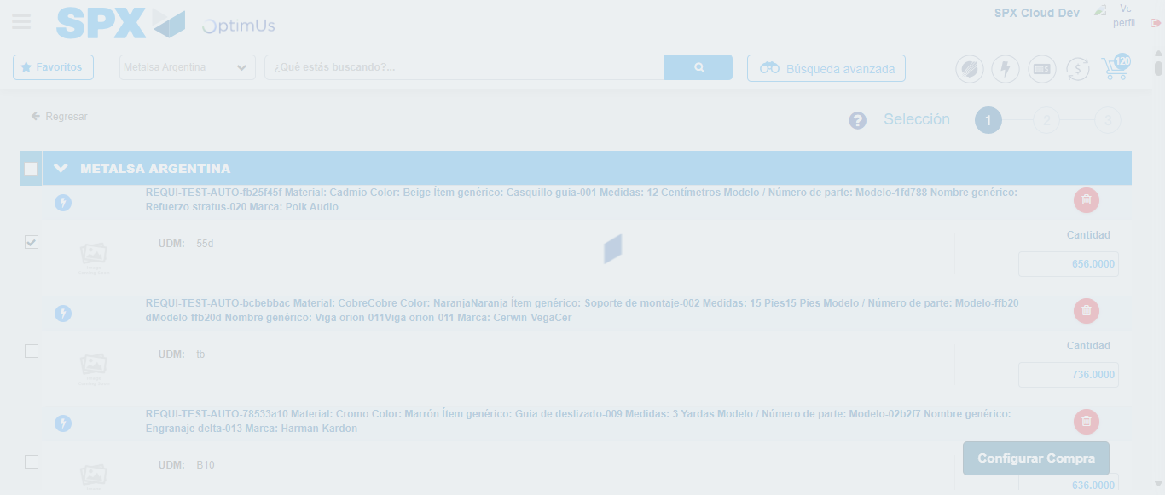Image file-name: QC_Testing-runTestMultipleTimes-nov. 25 2025, 03 59 18 p. m.

Step 5 - Select Type Account For Requisition : Type Account Correctly selected
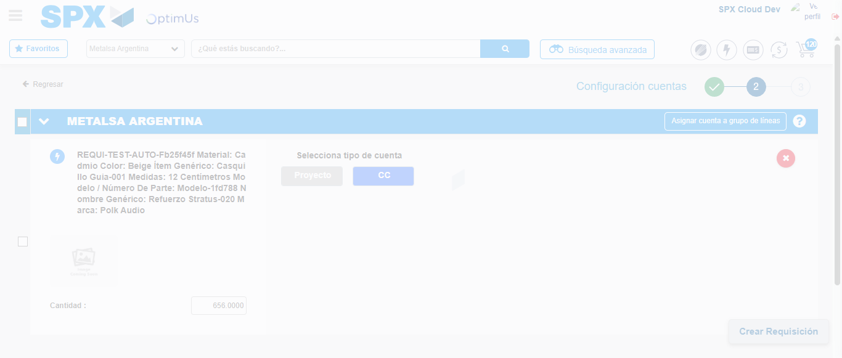Image file-name: QC_Testing-runTestMultipleTimes-nov. 25 2025, 03 59 21 p. m.

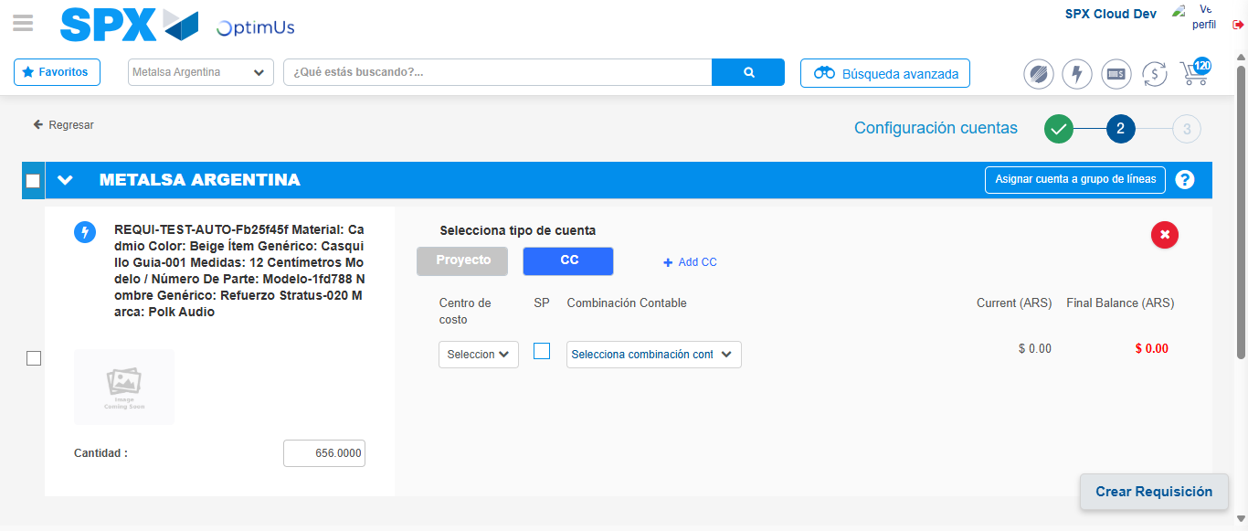Image file-name: QC_Testing-runTestMultipleTimes-nov. 25 2025, 03 59 24 p. m.

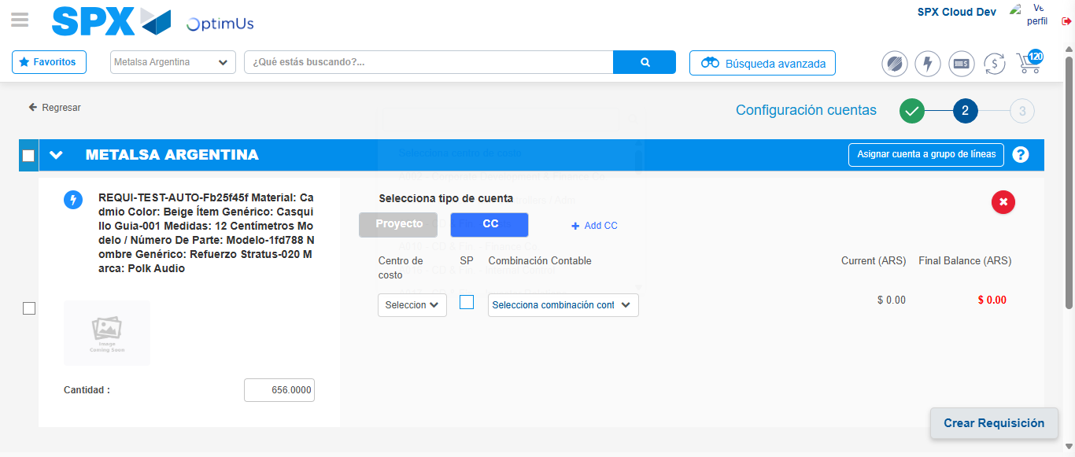Image file-name: QC_Testing-runTestMultipleTimes-nov. 25 2025, 03 59 27 p. m.

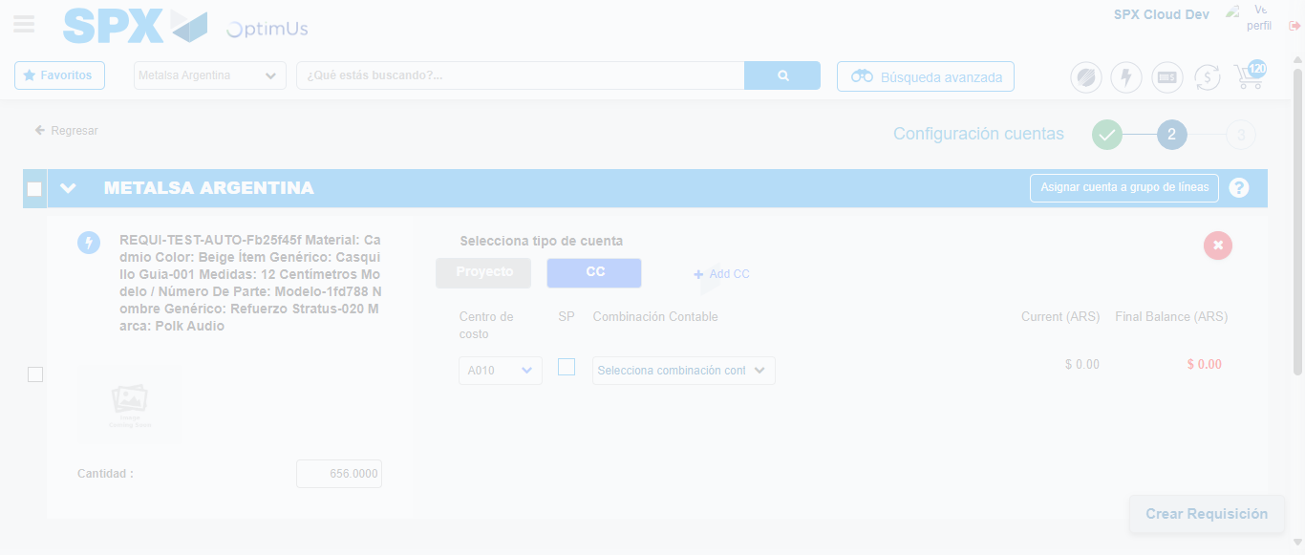Image file-name: QC_Testing-runTestMultipleTimes-nov. 25 2025, 03 59 28 p. m.

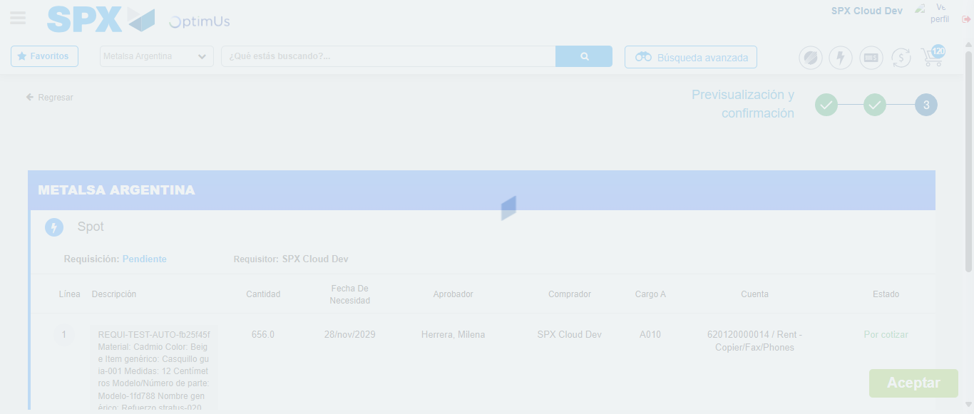Image file-name: QC_Testing-runTestMultipleTimes-nov. 25 2025, 03 59 31 p. m.

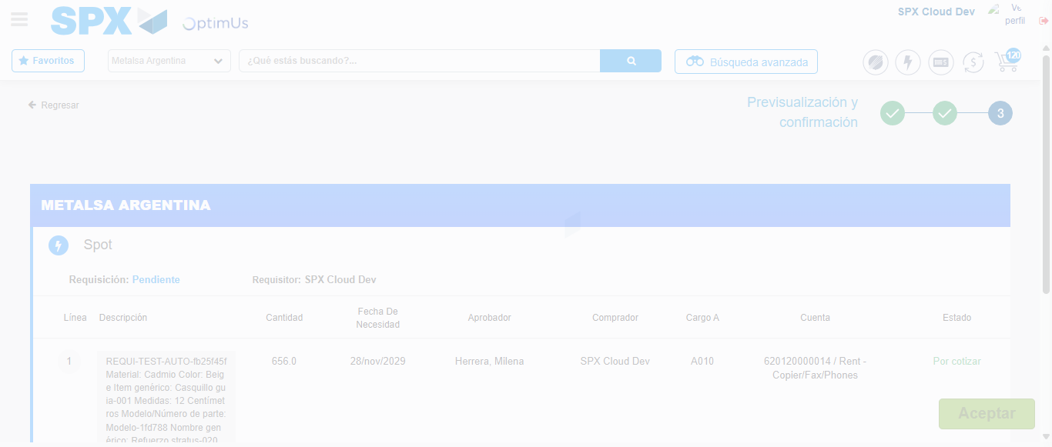Image file-name: QC_Testing-runTestMultipleTimes-nov. 25 2025, 03 59 35 p. m.

Step 6 - Accept to Requisition : Requisition Accepted
Image file-name: QC_Testing-runTestMultipleTimes-nov. 25 2025, 03 59 35 p. m.

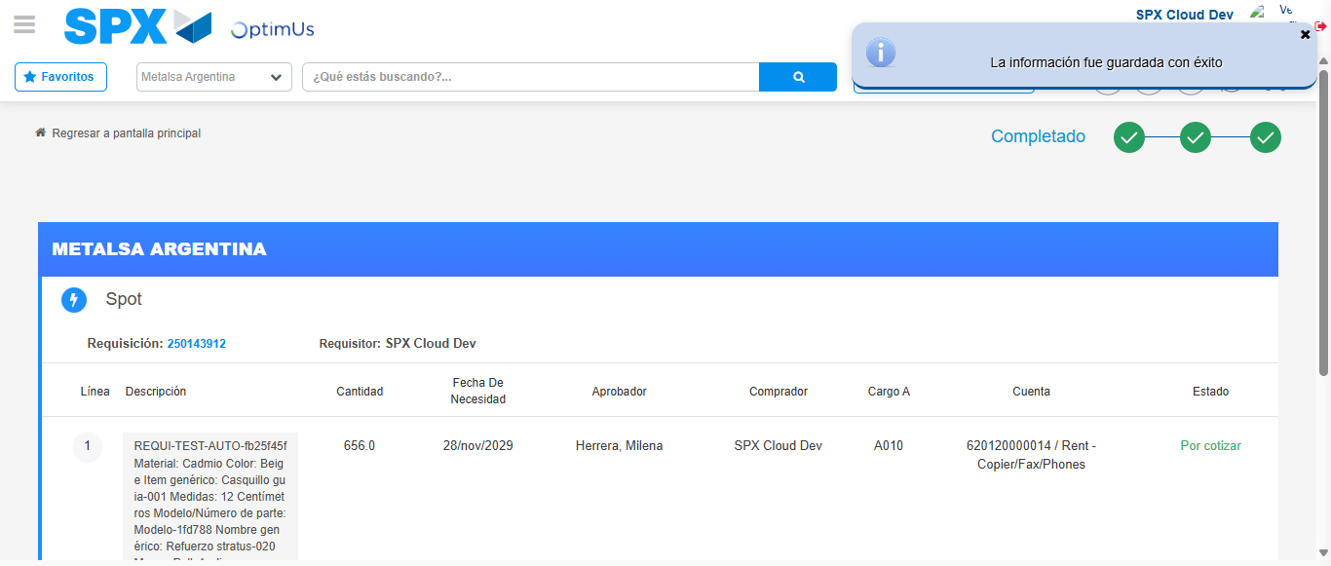Image file-name: QC_Testing-runTestMultipleTimes-nov. 25 2025, 03 59 39 p. m.

